SBA 2

Pgm 1

Code

**package** com.ust.test;

**import** java.util.*;

**public** **class** SBA2_1_ReverseString {

**public** **static** **void** main(String args[]) {

String initial, rev=" ";

Scanner sc=**new** Scanner(System.***in***);

System.***out***.println("Enter the string to reverse");

initial=sc.nextLine();

**int** length=initial.length();

**for**(**int** i=length-1;i>=0;i--)

rev=rev+initial.charAt(i);

System.***out***.println("Reversed string: "+rev);

sc.close();

}

}

Output

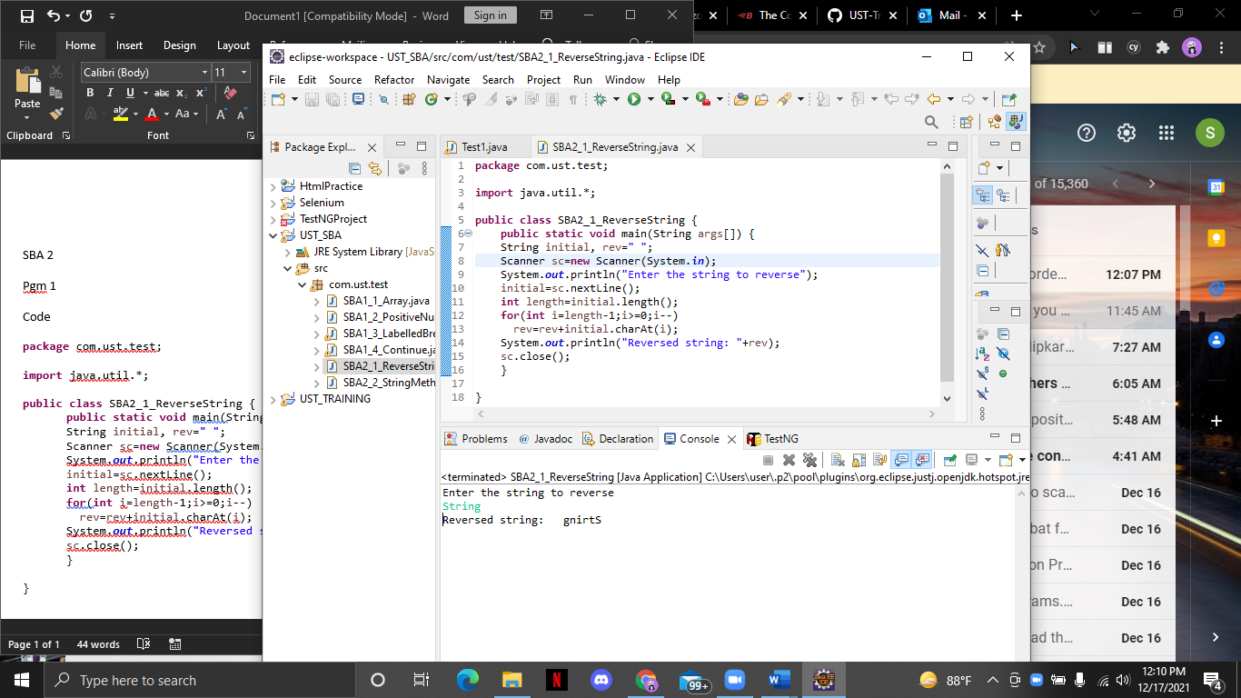

Pgm 2

Code

**package** com.ust.test;

**import** java.util.Scanner;

**public** **class** SBA2_2_StringMethods {

**public** **static** **void** main(String args[]){

**int** n = 0;

**switch**(n) {

**case** 1:

}

String str;

Scanner sc=**new** Scanner(System.***in***);

System.***out***.println("Enter a string");

str=sc.nextLine();

System.***out***.println("contains method:-");

**if**(str.contains("hello world")) {

System.***out***.println("The string contains hello world ");

}

**else**

System.***out***.println("The string does not contains hello world");

System.***out***.println("length method:-");

**if**(str.length()>0) {

System.***out***.println("String is not empty and length is: "+str.length());

}

**if**(str.length()==0) {

System.***out***.println("String is empty "+str.length());

}

System.***out***.println("replace method:-");

System.***out***.println("Before replace:"+str);

String replaceString=str.replace("hello","hi");

System.***out***.println("after replace:"+replaceString);

System.***out***.println("concat method:-");

System.***out***.println("string 1:"+str);

String str1;

Scanner sc1=**new** Scanner(System.***in***);

System.***out***.println("Enter a string");

str1=sc1.nextLine();

System.***out***.println("String 2:"+str1);

str=str.concat(str1);

System.***out***.println("after concat:"+str);

System.***out***.println("equal method:-");

String str2;

Scanner sc2=**new** Scanner(System.***in***);

System.***out***.println("Enter a string");

str2=sc.nextLine();

**if** (str.equals(str2)) {

System.***out***.println("both strings are equal");

}**else** System.***out***.println("both strings are unequal");

sc.close();

sc1.close();

sc2.close();

}

}

Output

